LAB 4 – Circular Convolution and Pitch Detection

This lab is on circular and linear convolution, as well as the implementation of autocorrelation in Android development. The lab will demonstrate:
- The difference between circular and linear convolution.
- How convolution can be used in signal processing applications
- Implementing convolution in Python and extending the concept to Android development using Kotlin and Jetpack Compose.

Part 1
As established in previous labs, convolution is a mathematical operation that blends two signals to produce a third signal. In DSP, it can be used for:
- Filtering signals (e.g., smoothing, sharpening)
- Feature detection in images and audio
- System response calculations
Linear convolution has already been explored in previous labs. This lab will pick up from there and show the difference in implementation between linear and circular convolution.
Circular convolution is performed in the frequency domain by multiplying the Discrete Fourier Transform (DFT) of two signals. Refer to lecture slides 9 and 10 for a more detailed breakdown of the mathematics behind the concepts.

Experiment 1
- Generate any two signals of your choice in the time domain.
A sine and cosine wave were generated with frequency of 500 Hz defined on time interval of 0 to 0.01 seconds with sampling rate of 20 KHz.
- Compute the linear convolution using NumPy, ie, the manual approach.
- For the same two signals you generated, use the inbuilt scipy library to perform the convolution.
- Plot the two and state your observation of the differences in the two approaches if any.
Between the manual and scipy convolution, they are both identical. 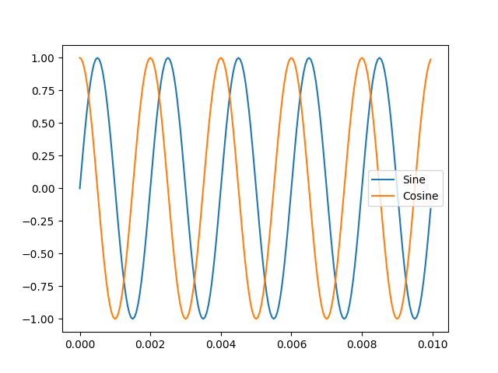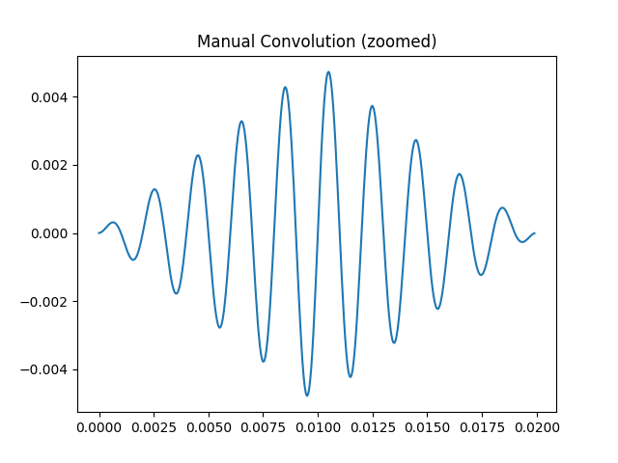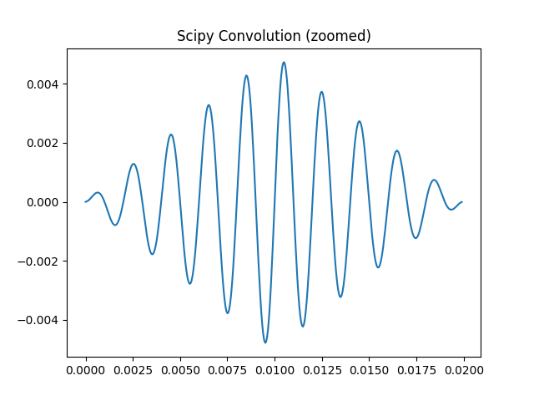
- What do you observe about the length of the convoluted signal? How would you express this algebraically?
The length is double the time interval of where the original signals are defined if they are both of length N, i.e., the resulting convolution will have length of 2N - 1.
- Now perform circular convolution manually. Refer to the slides for the formula.
- Plot the new convolved signal.
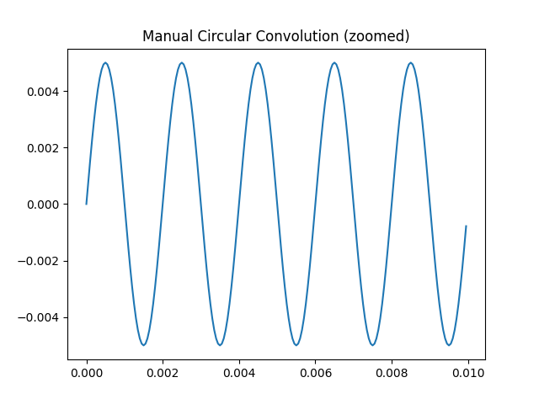
- Again, using the scipy library, perform the circular convolution using the inbuilt function.
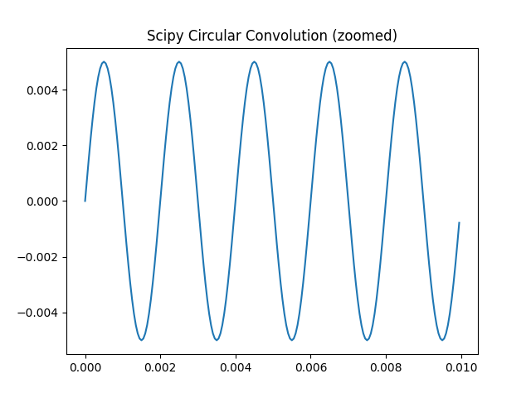
- What differences do you observe between the two? Is there a need for zero-padding in the manual approach to match the output of the inbuilt function?
They are both identical indicating the two methods to compute circular convolution are correct; zero-padding is needed for manual circular convolution if the two signals are different lengths in order to have same length for both signals.
- Plot the convolved signal and state your observations and answers in your report.

Assignment 1
- Attach all the plots and code to your report as well as your observations.
import numpy as np
import matplotlib.pyplot as plt
from scipy.signal import convolve
from scipy import ndimage
from scipy.fft import fft
fs = 20000T = 0.01t = np.linspace(0, T, int(T*fs), endpoint=False)
seg1 = np.sin(2*np.pi*500*t)
seg2 = np.cos(2*np.pi*500*t)
# Plot signalsplt.figure()
plt.plot(t, seg1, label = 'Sine')
plt.plot(t, seg2, label = 'Cosine')
plt.legend()
plt.show()
# Manual convolutiondef linear_convolution(x, h):
N = len(x)
M = len(h)
y = np.zeros(N+M-1)
for n in range(N+M-1):
for k in range(N):
if 0 <= n-k < M:
y[n] += x[k] * h[n-k]
return y
def circular_convolution(x,h):
N = len(x)
if len(h)!=N:
h = np.pad(h, (0,N-len(h)))
y = np.zeros(N)
for n in range(N):
for k in range(N):
y[n] += x[k] * h[(n-k)%N]
return y
def scipy_convolution(x, h):
N = max(len(x),len(h))
X = np.fft.fft(x)
H = np.fft.fft(h)
Y = X*H
y = np.fft.ifft(Y)
return np.real(y)
dt = 1/fs
manual = linear_convolution(seg1, seg2) * dt
conv_np = convolve(seg1, seg2, mode='full') * dt
manual_circular = circular_convolution(seg1, seg2) * dt
circ_np = scipy_convolution(seg1, seg2) * dt
# Time axest_conv = np.arange(0, len(manual)) * dt
# Plot convolutionplt.figure()
plt.plot(t_conv[:2000], conv_np[:2000])
plt.title("Scipy Convolution (zoomed)")
plt.show()
plt.figure()
plt.plot(t_conv[:2000], manual[:2000])
plt.title("Manual Convolution (zoomed)")
plt.show()
plt.figure()
plt.plot(t[:2000], manual_circular[:2000])
plt.title("Manual Circular Convolution (zoomed)")
plt.savefig("manual_circular.png")
plt.show()
plt.figure()
plt.plot(t[:2000], circ_np[:2000])
plt.title("Scipy Circular Convolution (zoomed)")
plt.savefig("scipy_circular.png")
plt.show()

- What differences do you observe in the plots of the circular and linear convolutions?
- What happens if the two input signals have different lengths in circular convolution? How should the shorter one be handled?
- What inferences can you make about linear and circular convolution?
- Why the need for zero-padding?
- In what situations might you want to use one type of convolution over the other?
- State some applications of both types of convolution.

Part 2
This part of the lab involves you building a basic app using Android Studio. You are free to design the user interface (UI) however you see fit as a group, but the app should still meet the core functionality to be described.

Experiment 2
- Unlike Python, Kotlin does not have built-in FFT convolution, so you will need to use the JTransforms library for FFT-based circular convolution.
- Import it for use as follows:
- Using the two signals you used from the Part 1 as input, compute the circular convolution using FFT.
- This involves
- Converting the time-domain signals to the frequency domain using FFT
- Multiplying the frequency domain representations
- Convert back using inverse FFT. In the attached screenshot, Y is the convoluted signal.
- Plot the original and convoluted signals.
- Some example UI Components you can include;
- Input UI:
- Two sliders for signal length
- Dropdown to select signal type (sinusoidal, square, impulse)
- Processing UI:
- Button to compute circular convolution

Assignment 2
- Attach screenshots of the app created with the UI you created.
- Attach the original and convoluted signals.
- How does FFT help speed up circular convolution? What is the computational complexity?
- Compared to the circular convolution performed using Python, what differences do you observe with the app you created in terms of size, memory used and time taken to compute the convolution?
- Give reasons for your observations from question 4.
- If two signals of length N are convolved using circular convolution, what will be the length of the result? Why?

Part 3
This section builds on Lab 3 and tasks you with designing an Android app to explore a practical example of Autocorrelation. It involves real-time pitch detection.

Assignment 3
- In Assignment 5 of lab 3, you were tasked with writing code in Python to record a speech signal and detect the pitch.
- Design an Android app (again, you are free in your choice of UI design) to detect the highest pitch of any real-time speech.
- Attach screenshots of your built app and show your built working app to the TA anytime after the submission of the report.

